Jiang Xueqin
- I think that the war in a gulf is mainly about maintaining the petro dollar.
- ‘If US can weaponize dollar against Rusia, they can do it against everybody. That is why there is a run out of US treasury, as it is not politically save’
- ‘America used to be policeman of the world and now it is a pirate of the world’ 3:25
- Iran wants guarantees for a security for itself and its proxies
- What is the point of a ceasefire? Trumps main objective is to strengthen a petrodollar. To force China and Europe to buy energy in US Dollar . So maybe the goal of this war was to destroy Iranian and Gulfs States capacity to provide oil to the world?
- Iran is a pressure point in China economy (its supply 90% of Chinese imported oil) 8:50
- China is buying oil in sanctioned countries, which helps them to get them at very discounted price
- I believe this is the grand US strategy to choke Far East by controlling Ormuz and Malaka straits.
- One of the biggest temporary goals of the US is to secure its debt (current and future).
- Based on this theory, if Iran is threatening US with its attack into Gulf States infrastructure if US escalates, then it would play into US hand (would eliminate middle Eastern states as the oil suppliers, which would work short term.
- ‘Trump is the agent of the empire, he does what is required from him’ 18:30
- Trump thinks that if they can’t impose tariffs, they will impose tolls.
- If Democrats will go back to power in 2028, there will not roll back those tolls, they will institutionalize it.

- There are limitations to Chinese strategic thinking. Silk and Road initiative was a good concept and choice. You secure resources and trade routes from the US. The problem is, the US was protecting sea lines. What would happen if US, one day, decided to steal the cargo?

- In long term, Russia will challenge US maritime dominance. What will going to happened is, Russia will start to arm their shadow fleet. Rusia cannot dream about defeating US on high seas, but they will start a war of attrition
- - Democrats (globalists) are pro war (with Iran). They see Trump as the useful idiot that will be a scapegoat. They are not only not stopping him from conducting this operation, but they are actively disallowing antiwar rhetoric during ‘no-king’ movements.

Glenn Diesen:
- In most wars US starter or joined, the economical incentives were very strong but it is hard to understand how current (vs Iran) war support US economy.
- If Americans will try to block Ormuz, then Houthis would block Red Sea, which is a weak?? Point of this plan.
- ‘Energy from Russia to Europe will start to flow when US takes control over Nord Stream’
-Trump want to monetize US empire in a better way. States protected by the US should pay for it.
- Looking at how US is behaving, Middle East, Africa and Europe will happily join the ‘Heathland Cooperation’ and ditch US and UK.
- US will send troops to make as much chaos as possible to disrupt region and to undermine belt and road initiative
-in Samuels Huntington work in 2004 ‘Dead Souls’ globalists created the world elite that was detached from the nations. There, Huntington suspects that next systematic war will be between Globalists and Nationalists.
Questions:
How will a Petro-currency (collar, euro, yuan) look like when countries will stop relay on external fuel sources? Maybe a hunger for the energy will be so huge that states will always need additional energy, beside produced domestically yet, how are you going to construct a world financial system over the energy that can be generated everywhere.

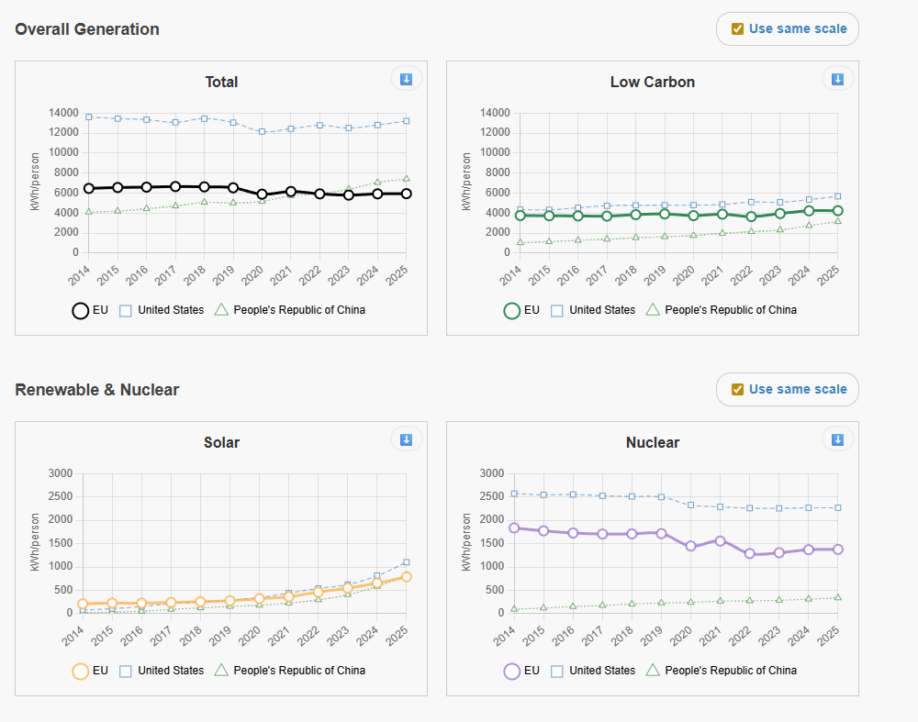
一https://lowcarbonpower.org/region/EU

Isint it something that the world is already doing?
I think that this is the case of retrospectively adding narrative to what happened because US administration was surprised that horizontal escalation happened. Moreover, if the attack on Iran would succeed, then Gulf States would not need security guarantiees of US and its power over them would diminish. It just doesn’t add up.
Officially it is 0%, I don’t have a source for that 90% statement
That is why China is building alternative routs on land
That is why China is rapidly increasing its naval force
I really don’t think that Russia have any options to fight US or anybody on the sea… They are getting beaten up on a Black Sea by a state that doesn’t even have fleet.
I would say that preventing competitors in the oil market to earn money could be the kind of a reason (but then… they lift sanctions on Russian oil)
Isint oil and gas diminishing in the world (and developed country) mix? US would have to start destroying off shore wind farms and start blocking sun to make oil great again
‘protected’… from itself
So war between US and Russia (even if fought via proxies) and China is a war between globalists and nationalists??? Because MAGA doesn’t sound very globalistic.

